Ecris le nom des animaux sous les illustrations.

**Ecriture**

Le

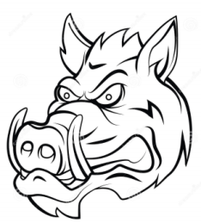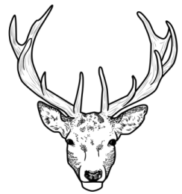

**CERF SANGLIER**

|  |  |  |
| --- | --- | --- |
|  |  |  |

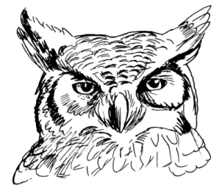

**HIBOU ECUREUIL**

|  |  |  |
| --- | --- | --- |
|  |  |  |

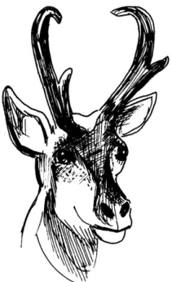

**RENARD CHEVREUIL**

|  |  |  |
| --- | --- | --- |
|  |  |  |